# ENGG1500 – Software Engineering

# Assessment 4 – Project Testing

Due: Week 11 of semester 1, 2017

This assessment will be broken into three components; the online submission in blackboard, adding your application to [Google Play](https://play.google.com/store?hl=en), and the test day demonstration.

## Online Submission

Due 11:59pm Monday 15th May, 2017.

One student from each group must submit:

1. A group cover sheet
2. Both a .apk and .aia file for their associated program. Please see Appendix 1 for details on how to generate these files.
3. A .pptx consisting of 2 or more slides:
   1. Slide 1: (mandatory) Title Slide, with your group name and group member names
   2. Slide 2: (mandatory) A slide listing any dependencies required to run your program. This can be related to any other applications which need to be installed on the phone for your program to run (for example, a .pdf viewer) as well as any other details required to run your application
   3. Slide 3: (if required) For groups using QR code verification, place the desired QR code (for successful Check-in) on this slide.
   4. Other details: If necessary, include any other miscellaneous details regarding your program on the following slides.

**Late Submissions:** The mark for an assessment item submitted after the designated time on the due date, without an approved extension of time, will be reduced by 10% of the possible maximum mark for that assessment item for each day or part day that the assessment item is late. Note: this applies equally to week and weekend days.

## Google Play

Due 11:59pm Monday 15th May, 2017.

All applications will be uploaded to Google Play for distribution. For details on how to upload your application to the Google Play, please see Appendix 2.

Note: it is imperative that the file distribution component of your application is set to download/view this file: **TBA**

You will be using a designated google account to upload the application. Applications cannot be uploaded concurrently so a timetable for when you can upload will be arranged with your tutor during lab of week 10. Allow 15 – 20 minutes to upload the application.

Before uploading to Google Play you will need:

The .apk file which will be uploaded to Google Play. See appendix 1 for details on how to generate this file.

Promotional images for the listing:

All application must have:

**screen shots (.jpg or .png, minimum dimension: 320px, maximum dimension: 3840px)  
high resolution icon (.png, 512px by 512px)  
feature graphic (.jpg or .png, 1024px by 500px)  
promo graphic (.jpg or png, 180px by 120px)**

**Ensure all images used do not contain content with unauthorized copyright content in the promotional material. Images with unauthorized content will be rejected and will not be uploaded to the Google Play.**

## Test Day

11am – 1pm Wednesday 17th May, 2017, ES105

During the normal software engineering tutorial, all applications will be presented to the markers and class. Everyone will have the option to download and run each groups application.

## Marking Criteria

|  |  |  |
| --- | --- | --- |
| Property | Description | relative worth |
| Presentation / User Interface | The application must look good. Think about simple branding features as well as symmetrical layouts. | 20% |
| Robust Application | The application should give meaningful error messages, and make use of conditional statements so that incorrect data cannot be passed to the server.  A user should not be able to make incorrect selection when using the application, for example; the user cannot download the files unless they have successfully checked-in.  Any dependencies required to make the application work must be accounted for in the design documentation. | 40% |
| Robust server interaction | The application should send details to the server in the required format.  The application should make use of the responses from the server, to provide meaningful statements to the user about their check-in status. | 20% |
| Cannot Cheat the System | The application will cater for students who attend the lecture. The design should include safeguards, so that students cannot check-in if they are not at the lecture. | 20% |
| Innovation feature | Extra marks are available for groups who add innovative (unspecified) features into their design. | 10% |

## Appendix 1

### Step 1:

If you have been using debug modules during the development of your application, ensure they are removed before submission

### Step 2:

Check that the following properties have been set within your project: VersionCode and a VersionName.

These fields are required for applications in Google Play and can be found on the designer page for screen 1, at the bottom of the properties window:

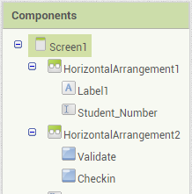 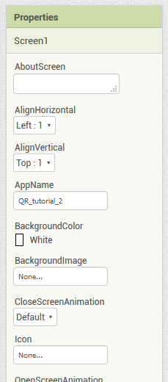

…

Select the Screen1 component and check the properties tab for VersionCode and VersionName

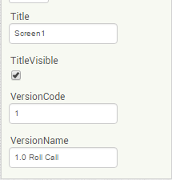

These values should be set to the default settings:

VersionCode = **1**VersionName = **1.0 Roll Call**

### Step 3:

The source code is represented as an **.aia file**. To generate the **.aia file**, from the build environment with the project loaded, select the menu option **projects 🡪 Export selected project (.aia) to my computer**

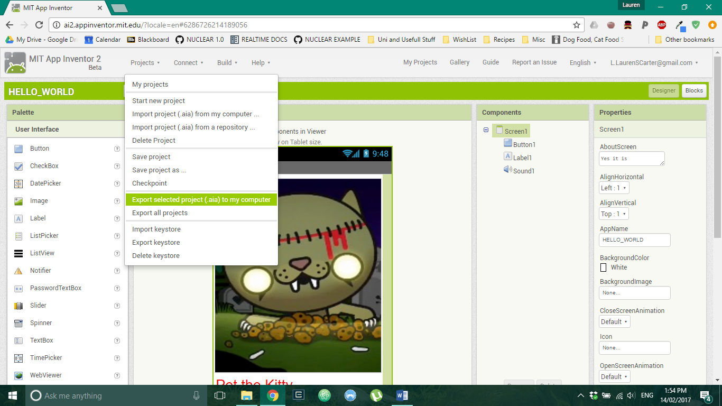

### Step 4:

The built code is represented as a **.apk file**. To generate the **.apk file**, from the build environment with the project loaded, select the menu option **build 🡪 App**. Use the second option **(save to my computer)** then download as an **.apk file.**

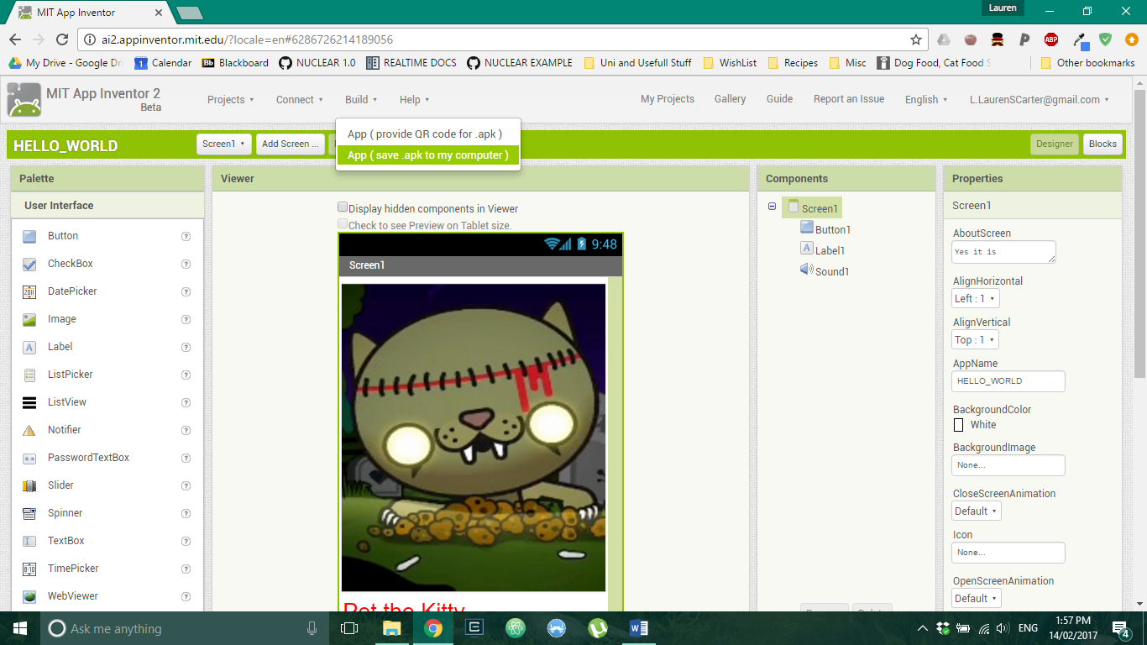

### Step 5:

For submission to blackboard, put the files in a zip folder along with the power point presentation and group coversheet.

## Appendix 2

### Step 1

Visit the [Google Play Console](https://developer.android.com/distribute/console/index.html), and login with the sample developer account.

[L.LaurenSCarter@gmail.com](mailto:L.LaurenSCarter@gmail.com)  
t3mp0r4ry

### Step 2

Once logged in, select CREATE APPLICATION.

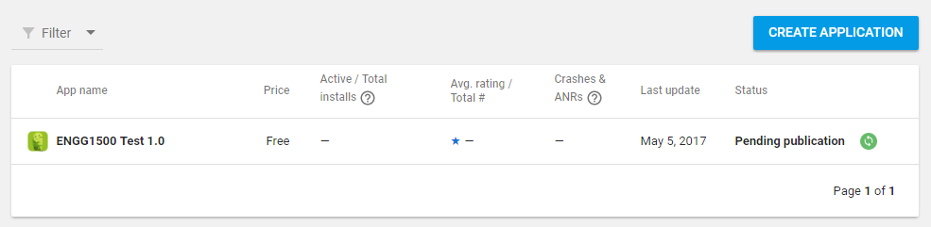

### Step 3

You will go through the application wizard.

Select English (United Kingdom) – en-GB

Give your application a title: ENGG1500 ROLL CALL GROUPN  
*(replace N with your group number)*  
___________________________________________________________________________

**Product Details**

Fill in the short description and long description.

Add any [graphic assets](https://support.google.com/googleplay/android-developer/answer/1078870) used to represent the application. Ensure that the files uploaded to this section meet the requirements listed by google on their [graphic assets](https://support.google.com/googleplay/android-developer/answer/1078870) page.

All application must have:

**screen shots (.jpg or .png, minimum dimension: 320px, maximum dimension: 3840px)  
high resolution icon (.png, 512px by 512px)  
feature graphic (.jpg or .png, 1024px by 500px)  
promo graphic (.jpg or png, 180px by 120px)**

Any other graphic assets are optional

___________________________________________________________________________

**Categorization**

Application type: Applications

Category: Education

Content Rating: Leave as default

___________________________________________________________________________

**Contact Details**

Leave as default settings

___________________________________________________________________________

**Privacy Policy**

Select the checkbox for “Not submitting a privacy policy URL at this time”

Scroll to the top of the page and select SAVE DRAFT

Use the Dashboard on the left to navigate to the App releases section.

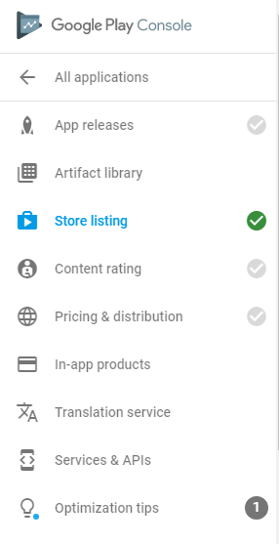

If you cannot see the Dashboard, click on the Dashboard icon in the top panel



In this section you will upload the .apk:

Select MANAGE PRODUCTION  
Select CREATE RELEASE  
Select UPLOAD APK  
Select BROWSE FILES  
Navigate to the .apk, select the file and click on open  
Add some release notes. For example, “Initial published version of the application.”  
Scroll to the bottom of the page and select SAVE

Navigate to the Content rating

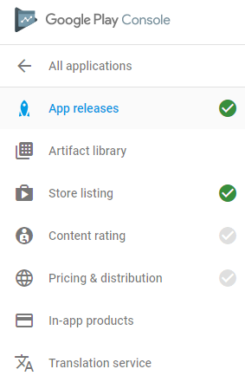

Read through the disclaimer, and click CONTINUE  
Enter the email address [L.LaurenSCarter@gmail.com](mailto:L.LaurenSCarter@gmail.com)  
Select application category “REFERENCE, NEWS, OR EDUCATIONAL”  
Select No for VIOLENCE, SEXUALITY, LANGUAGE AND CONTROLLED SUBSTANCE  
Select Yes for:

“Does the app natively allow users to interact or exchange content with other users through voice communication, text, or sharing images or audio?”

“Does the app share user-provided personal information with third parties?”

Select No for:

Does the app share the user's current physical location to other users?

Does the app allow users to purchase digital goods?

Select SAVE QUESTIONNAIRE  
Select CALCULATE RATING  
Select APPLY RATING

Navigate to Pricing & distribution

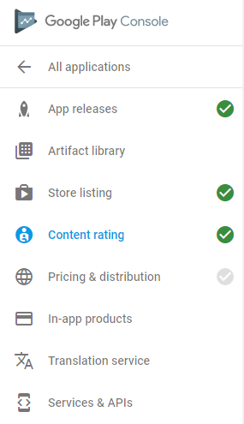

Leave the default price set to FREE  
Set available in Australia  
Select No for Primarily Child-Directed and Contains ads  
Do not make any changes in Device categories or User programs  
Check all boxes under Consent  
Scroll to the top of the page and select SAVE DRAFT

Select Ready to publish  
Select MANAGE RELEASES  
Select EDIT RELEASE  
Select REVIEW  
Select START ROLLOUT TO PRODUCTION  
Select CONFIRM

**NOTE: it may take up to 24 hours for the application to become available in Google Play.**